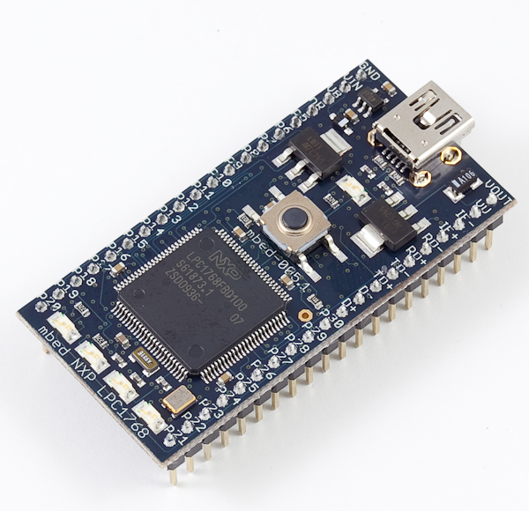

LED4

LED3

LED2

LED1

RESET BUTTON

1. Make sure the modem is connected to the red PCB and insert an MTN sim card into the modem.
2. Make sure that the sim card is meant to be for a USB Modem and load it with credit.
3. Connect the MBED to a USB port on a computer and press the reset button
4. Note down the status of the LEDs i.e. if LED1 lights up, note it down
5. Also note down the colours of the modem light i.e. green/ blue/light blue/ flashing
6. Email us the results